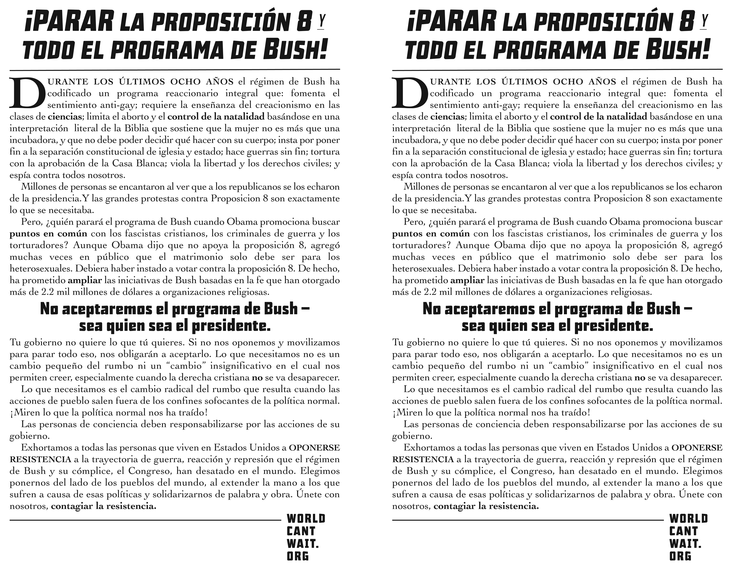
Enter local information here – change fonts if you like, including size – to print, give this Word document AND JPG that should have accompanied this flyer to the printer

Enter local information here – change fonts if you like, including size – to print, give this Word document AND JPG that should have accompanied this flyer to the printer

